


Enduro European Championship
Supplementary Regulations

Title of the meeting: 2 - nd Round Enduro European Championship 2012

Venue: Paikuse, Pärnu county, Estonia EMN: 30 \ 2
Classes: E1 Junior, U20 Junior 125 2T, E2/E3 Junior, E1 E2 E3 Senior, Veteran, Woman
Date: 21-22 July 2012
Organizing FMN: EMF Country: Estonia
Access: GPS N58⁰ 22´ 23´´ E 24⁰ 36´49´´
Nearest Airport: Estonia, Tallinn airport – 132km and Latvia, Rigas airport – 179km
Motorway: E67 from Tallinn to Pärnu turn left in Pärnu to local road 59 or E67 from Latvia to Pärnu turn right in Pärnu to local road 59 and 3km to paddoc.
Nearest town: Pärnu, 6 km from the circuit
Nearest Hospital: Pärnu central hospital, 11km from the circuit.
Hospital address: Ristiku 1, Pärnu +372 447 3301

ORGANIZER: Paikuse MK
Address: Paide mnt. 19a, Paikuse, Pärnu county 86602, Estonia
Phone: +372 51 39 040 or +372 50 52 554 FAX: +372 44 53 392
E-mail: paikuseenduro@gmail.com
Web.site: www.paikuse-enduro.eu

ENTRIES:
Entries must be made on the official entry form and sent to the Secretary of the meeting before 20 of june 2012 (30 days prio the event).
Address: Paide mnt 19a, Paikuse, Pärnu county 86602, Estonia
FAX: +372 44 79 999
E-mail: paikuseenduro@gmail.com
The entry fee of 130€ euros must be received to the organizer account by 20 of june 2012 (30 days prio the event-closing date). Late entries and entery fees are accepted but with additional fee 50€ euros. Entry fee must be sent to:
MTÜ Paikuse MK, SEB Bank
IBAN: EE711010902001122004 BIC: EEUHEE2X

WELCOM CENTER:
Place: Paide mnt. 19, Paikuse
Open on: Thursday: from 13.00 to 16.00
Friday: from 12.00 to 17.00

ADMINISTRATIVE AND TECHNIKAL INSPECTION:
Administrative inspection from 10.00 to 16.00 on 20 of july 2012
Technikal inspection from 11.00 to 17.00 on 20 of july 2012
See attached Time Schedule.
COURSE:
DAY 1: Start at 10.00. The course of the first day shall consist of 3 laps of a 180 km course which will include 2 timechecks per lap. There will be a total of 3 special tests(extreme, enduro and cross) per lap and will be timed tests.
DAY 2: Start at 09.00. The course of the second day shall consist of 3 laps of a 180 km course which will include 2 timechecks per lap. There will be a total of 3 special tests(extreme, enduro and cross) per lap and will be timed tests.
PRICE-GIVING CEREMONY: about 17.30
Riders who qualify for prizes are invited to attend the prize-giving ceremony.
There are will be awarded first three riders from each class and three overall riders.
JURY MEETINGS:
The first Jury meeting will be held at 20 of july 2012 at 9.00
Subsequent jury meetings will be at times decided by the Jury President and these will be displayed on the Jury room door.
RECONNAISSANCE OF THE COURSE
Meeting point: At the start, on 20.07.2012 at 11,00

TRAINING AREA:
3 km from the paddoc and open from 19-20 of july 2012 at 10.00 to 16.00

OFFICIALS:
Jury President: Pavol Sas FIM Lic. Nr. 4645
FMNR Jury member: Toivo Kaldmäe FIM Lic. Nr.
Secretary of the Jury:
Clerk of the course: Sulev Tõnisson FIM Lic. Nr. TBA
Secretary of the meeting: Avo Sirel
Chief Technikal Steward: Allan Laurimäe FIM Lic. Nr.
Chief Timekeeper: FIM Lic. Nr. TBA
Environmental Steward: Lembit Miil FIM Lic. Nr. 6989
Chief Medical Officer: Külvar Mand FIM Lic. Nr. 5920
Press Officer: Robert Pairan

ACCOMMODATION:
www.klaaramanni.ee +372 4475 575
www.linnamehe.ee +372 517 8379
www.reldor.ee +372 4478 410
www.aleksandripub.ee +372 4432 186
www.konse.ee +372 5343 5092
www.emmi.ee +372 4476 905
www.viiking.ee +372 4490 505
www.aisa.ee +372 4438 044
www.strand.ee +372 4475 389
www.perghotels.ee +372 4478 911
www.terviseparadiis.ee +372 4451 600 +372 4479 219
www.spaestonia.ee +372 4476 830
www.soprus.ee +372 4450 795
www.sanatooriumtervis.com +372 4450 111

MISCELLANEOUS:
Approved by FMNR:
Veiko Biene
General secretary of EMF

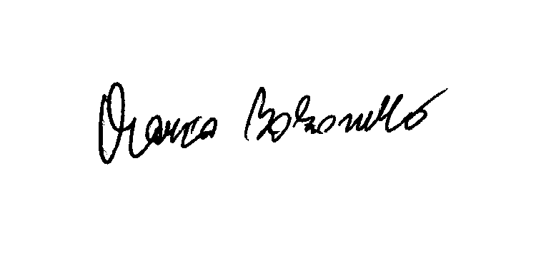
Approved by UEM:
Marco Bolzonello
UEM ERC
26th April 2012
TIME TABLE
 | Venue | Date | Time
 | PAIKUSE - ESTONIA | 20 July 2012 | ADMINISTRATIVE | TECHNICAL
1 | Estonia EMF |  | 10:00 | 11:00
2 | Latvia LAMSF |  | 10:15 | 11:15
3 | Sweden SVEMO |  | 10:25 | 11:25
4 | Finland SML |  | 10:50 | 10:50
5 | Russia MFR |  | 11:10 | 12:10
6 | Poland PZM |  | 11:15 | 12:15
7 | Germany DMSB |  | 11:35 | 12:35
8 | Hungary MAMS |  | 12:05 | 13:05
9 | Slovakia SMF |  | 12:10 | 13:10
10 | Austria OAEMTC |  | 12:30 | 13:30
11 | Norway NMF |  | 12:40 | 13:40
12 | Czech Republic ACCR |  | 12:45 | 13:45
13 | Rumania FRM |  | 13:10 | 14:10
14 | Belgium FMB |  | 13:15 | 14:15
15 | Nederlands KNMV |  | 13:30 | 14:30
16 | Suisse FMS |  | 13:55 | 14:55
17 | Italy FMI |  | 14:10 | 15:10
18 | France FFM |  | 14:40 | 15:40
19 | Great Britain ACU |  | 15:10 | 16:10
20 | Espagna RFME |  | 15:40 | 16:40
20 | Portugal FMP |  | 15:45 | 16:45
21
22

